# PARKING ASSISTANCE ON A CROWDED ROAD USING INDUCTIVE LOOP & IOT

# *1*Amruta Chore, *2*Atul Kumar, *3*Aniket Londhe, *4*Govind Kumar

*1Asst. Professor, Electronics & Telecommunication, DYPIEMR,* [***amrutachore2404@gmail.com***](mailto:amrutachore2404@gmail.com)

*2Student, Electronics & telecommunication, DYPIEMR,* [***atulsriv.0308@gmail.com***](mailto:atulsriv.0308@gmail.com)

*3Student, Electronics & telecommunication, DYPIEMR,* [***londhe620@gmail.com***](mailto:londhe620@gmail.com)

*4Student, Electronics & telecommunication, DYPIEMR,* [***kumar.govind334@gmail.com***](mailto:kumar.govind334@gmail.com)

***ABSTRACT***

***This paper presents a design of smart parking system (SPS) which enables the user to easily find the nearest available parking space on a crowded road using inductive loop and IoT. This system avoids unnecessary fuel emission which happens during finding a parking slot on crowded roads and thus provides smooth transportation in over-crowded roads. The system comprises of an inductive loop vehicle detection sensor which detects the vehicle parked above the loop. The inductive loop not only detects a vehicle but also identifies the type of vehicle, e.g. Bike, car, bus or bi-cycle. The status/information of each loop can be accessed by the latest and booming technology trend that is IoT (Internet of things). The status of each loop is stored to the servers that can be easily accessed by every user by a GPRS enabled phone.***

***Keywords: Smart parking system (SPS), Internet of thing (IoT), Inductive loop, GPRS, Transportation.***

# INTRODUCTION

Traffic congestion caused by vehicle is a dire drawback at a world scale and it's been growing exponentially. Automotive parking drawback may be a major contributor and has been, still a serious drawback with increasing vehicle size within the luxurious phase and confined parking areas in urban cities. Finding out a car parking zone may be a routine (and typically frustrating) activity for several individuals in cities round the world. This search burns huge amount of fuel each day. Because the world population continues to urbanize without a well-planned system, automotive scenario can worsen.

There are three popular methods of vehicle detection system:

* Overhead level detector
* Ground level detector
* Underground level detectors

Overhead level detector system comprises of surveillance video cameras. A video camera sensors have accuracy issues in recognizing a tiny low vehicle (e.g., a traveller car) behind a giant vehicle (e.g., Toyota Innova or Xylo) in engorged conditions and area unit laid low with illumination issues, atmospheric condition conditions, shadows, water etc. Whereas, Vehicle detection using ground detector is done by using different types of sensors like Pneumatic sensors, magneto sensors, video image processors, IR sensors etc. However this has the downside that if 2 vehicles cross the tubes at an equivalent time then the direction cannot be accurately determined. Therefore the foremost economical methodology to find a vehicle is by underground level detector that uses inductive loops to detect a vehicle whose detection zone is most, cheap, and insensitive to any climate. Underground level detectors that are installed beneath paved surface have advantage on accuracy in investigation high capability in classifying vehicle of every type and needs less maintenance. This method eliminates all the issues associated with parking in jam-packed roads. The proposed system uses inductive loops that helps in detecting the vehicle and conjointly classifies the categories of vehicles e.g. bicycle, motor bike, car or bus. Sampling the loop at a high frequency ends up in a singular signature for every vehicle granting classification of the build. The setup consists of RF transmitters that transmits the data to the gateway. If the loop detects the vehicle the RF module sends the data to the gateway and classifies the car park as vacant or occupied. Gateway consists of ATMEGA16 that allows us to interface the RF module and conjointly provides enough fixed storage to store the information about the status of the loop. In order to access the information regarding the occupancy of the parking slots an internet page has got to be designed which can be accessed by GPRS enabled handsets. The gateway sends the information to the cloud which may be accessed by the web page. The webpage can show the status of parking slots by indicating the areas as vacant or occupied and conjointly classifies the type of vehicle already parked. The conclusion of the good town is currently turning into potential with the emergence of the net of Things (IoT) that radically evolves the present internet into a network of interconnected objects, like sensors, parking meters, energy mensuration devices and actuators. Wherever each object is unambiguously identiﬁed, and accessible to the network, its position and standing renowned.

**PROPOSED SYSTEM**

**Parking Loop X 3**-

Inductive Loop

Dual Power Supply

Pulse Shaping

LC, Pi Oscillator

CC2500 RF Module

AVR ATmega8

Fig. 1.1 Parking Loop Architecture

**Gateway**-

Dual Power Supply

GSM/GPRS Module

CC2500 RF Module

AVR ATmega16

Fig. 1.2 Gateway Architecture

**CC2500 -** The CC2500 is a low-priced a pair of.4 GHz transceiver designed for very low-power wireless applications. In this paper CC2500 module in loop detector system also as in gateway system has been proposed. CC2500 module in loop detector system is employed to transmit the updated frequency count to the CC2500 module of gateway system. CC2500 of gateway system receive this updated frequency and transfers the data to the Atmega16 for additional processing**.**

**GSM/GPRS Module** - GSM/GPRS module is employed to ascertain communication between microcontroller and a GSM-GPRS system so as to scan the RF signal and transfer this information to the server.

**Inductive loop -** Associate in nursing inductive loop consists of wire "coiled" to make a loop that typically may be a sq., circle or rectangular form that's put in into or underneath the surface of the parking slot. Inductive loop work sort of a detector as they live the modification within the field once objects pass/parked over them. Once a vehicle drives over a loop device the loop field changes that permits the detector device to detect the presence of a vehicle.

**Dual Power Supply -** In this paper designing of a twin power supply for each the systems e.g. for the loop detection system and also the gateway system as CC2500 and ATMEGA8 & 16 works on 3.3V and 5V respectively has been carried out. So as to possess 3.3V for the CC2500 module LM1117 voltage regulator and for 5V constant supply LM7805 voltage regulator has been proposed.

**ADAPTIVE ALGORITHM**

# Flowchart for parking loop detector- Flowchart of gateway-

START

START

Initialize LCD, Timer, SPI & RF

Initialize LCD, UART, GSM, SPI & RF

Load Set Point from EEPROM

Connect to GPRS

Connected?

No

Read Pulse

Vacant Space

Yes

No

Set Point > f?

Read RF

Yes

Upload data to server

Space Occupied

Yes

Uploaded?

RF Transmission

STOP

No

Fig. 1.3 Flowchart

**CIRCUIT DIAGRAM**

* **Parking Loop System -**

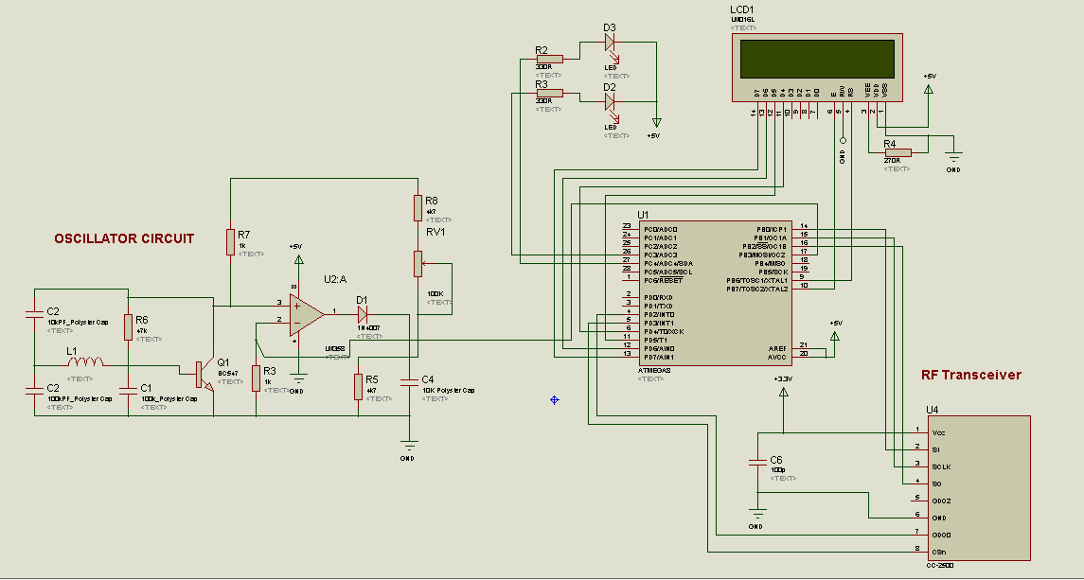

* **Gateway System -**

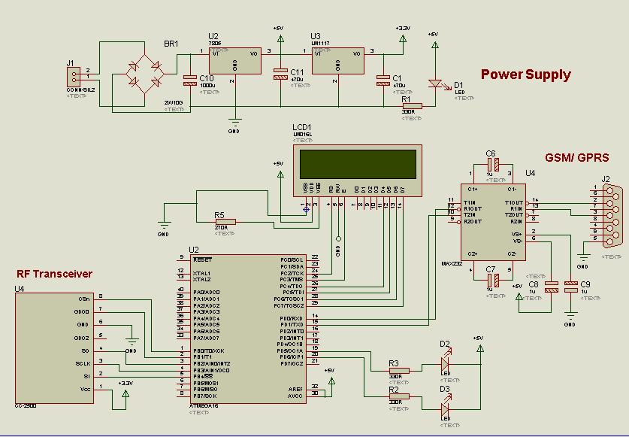

**CONCLUSION**

The system benefits of smart parking go well beyond avoiding the needless circling of city blocks. It also allows city to develop fully integrated multimodal intelligent transportation system. This system not only ease the tension of finding accurate space for each vehicle but also saves a numerous amount of fuel which is wasted in finding adequate parking slot. Finally in a long run smart parking system can actually transform the very makeup of our urban landscape.

# REFERENCES

[1] S. Sheik Mohammed Ali, Boby George and Lelitha Vanajakshi “A Multiple Loop Vehicle detection System for Heterogeneous and Lane-less Traffic” Indian Institute of Technology Madras, Chennai, India.

2] Mr. Basavaraju S R “Automatic Smart Parking System using Internet of Things (IOT)” Department of Information Science and Engineering, RV College of engineering Bangalore, Karnataka, India.

[3] C. Minsen, J. Ngarmnil and T. Rongviriyapanich “Embedded adaptive algorithm for multi-lanes-traffic inductive loop detecting system”. Electronic Engineering Department, Mahanakorn University of Technology, Thailand.

[4] Rakesh V.S*1*, Shaithya.V*2* “A Traffic Control System Using Inductive

Loop Detector” Assistant Professor, Dept. of ECE, Vidya Academy of Science and Technology, Thrissur, Kerala, India*1* , PG Student [Embedded Systems], Dept. of ECE, Vidya Academy of Science and Technology, Thrissur, Kerala, India*2*.

[5] Deep Desai and Sunil Somani “Instinctive Traffic Control and Vehicle Detection Techniques” Department of E&TC, MITCOE Pune, India.